=================== CORE JAVA by Ashok IT =====================
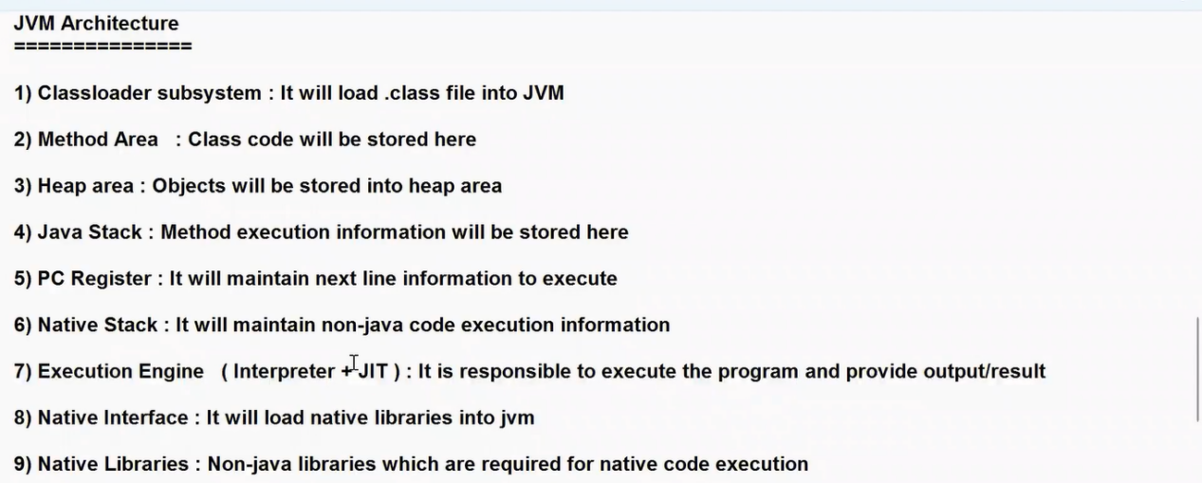

Conditional statements Conclusion ( if , if/else / switch )

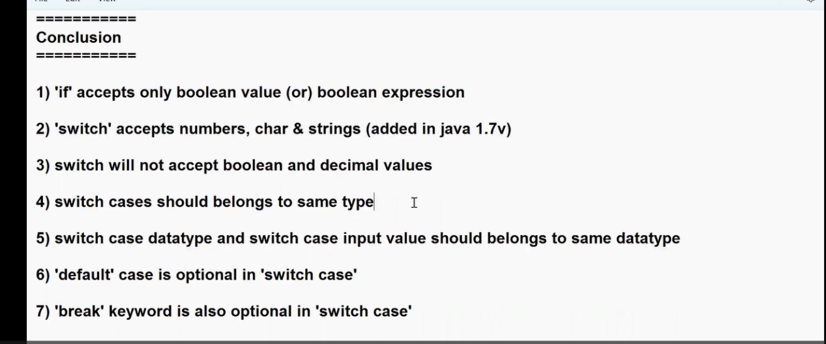

Array Key points

Array ni ye data type tho avina create cheyachhu but SIZE anedi only INT values and that to Positive values ne evvagalamu

Below code anedi Compile time Error evvadu because Array anedi Run time lo create avuthundi Compile time lo kadu.

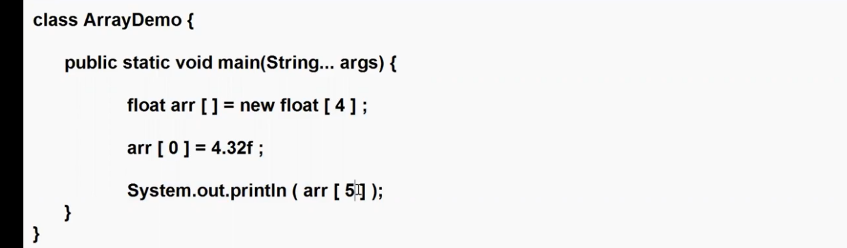

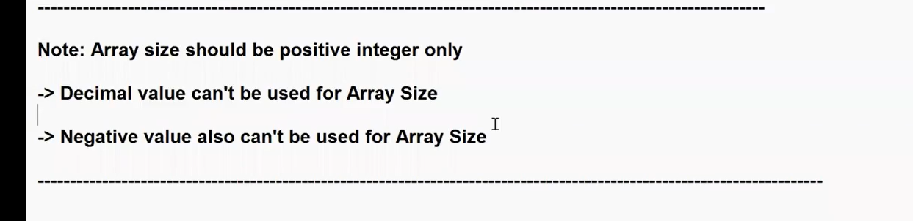

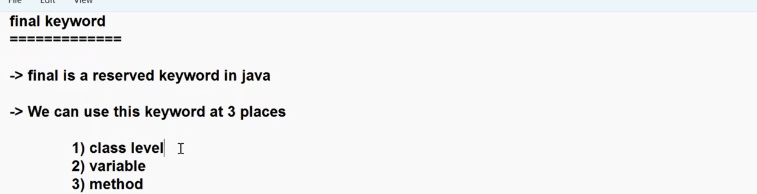

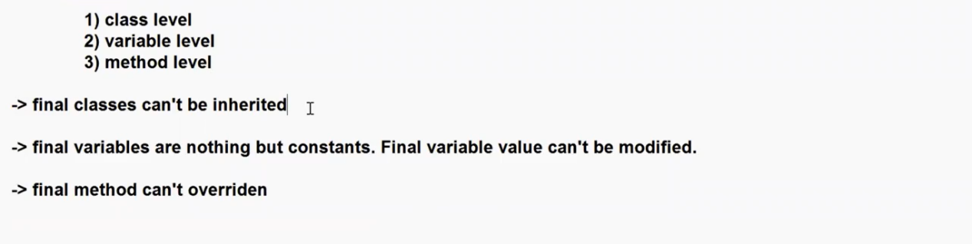

static methods also we can’t override then why we need to use final key word for methods?

✅ Key Point: final only affects instance methods

static methods already can't be overridden — so final is unnecessary for them but it allowed to write Finl key word static also if we write also no use
final is used mainly for instance methods — to prevent them from being overridden in a subclass.

Conclusion : final key word anedi methods topic ki vachhesariki Instance methods ni override cheyakudadu anukunte Instance methods ki use chesthamu

Feature | static | final
Belongs to | Class | Object
Overriding | ❌ Not possible (hidden) | ❌ Not allowed
Polymorphism | ❌ No | ✅ (but prevented)
Reason | Not part of object | Explicit restriction

One-line clarity
static methods don’t override by nature
final methods don’t override by restriction

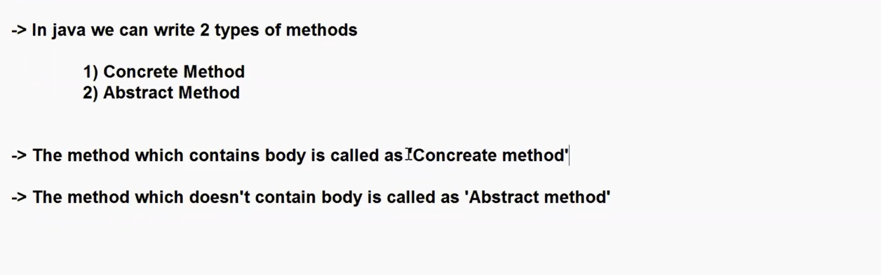

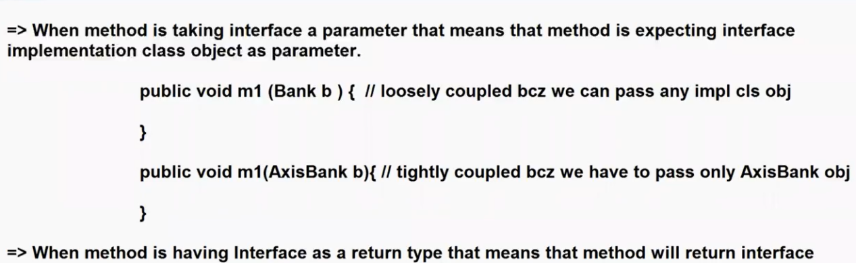

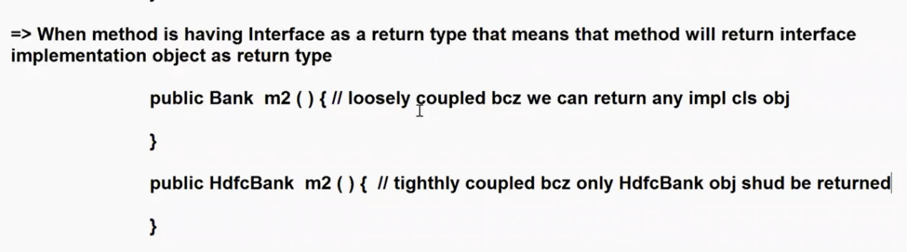

throw, throws, try-catch-finally.
✅ 1. Checked Exceptions
Definition: Exceptions that are checked at compile-time.
Examples: IOException, SQLException, FileNotFoundException, etc.

Use:
throws: Declares that a method might throw an exception.
throw: Actually throws the exception.
try-catch: Optional, but can be used to handle it instead of declaring it.
// Example with throws
public void readFile() throws IOException {
FileReader fr = new FileReader("file.txt");
}

// Example with try-catch
public void readFile() {
try {
FileReader fr = new FileReader("file.txt");
} catch (IOException e) {
e.printStackTrace();
}
}

✅ 2. Unchecked Exceptions (Runtime Exceptions)
Definition: Exceptions that are not checked at compile-time.
Examples: NullPointerException, ArrayIndexOutOfBoundsException, ArithmeticException, etc.

Use:
try-catch: Used to catch and handle them.
You don’t need to declare with throws, but you can if you want to.
public void divide(int a, int b) {
try {
int result = a / b; // Possible ArithmeticException
} catch (ArithmeticException e) {
System.out.println("Division by zero!");
}
}

Summary Table
Type | Compile-time Check | Common Use | throws Needed | Handle with try-catch
Checked Exception | ✅ Yes | IOException, SQLException | ✅ Yes (if not caught) | ✅ Yes
Unchecked Exception | ❌ No | NullPointerException, ArithmeticException | ❌ No | ✅ Yes

Clean mental model (remember this)

Concept | Purpose
throw | create exception
throws | declare exception
try-catch | handle exception

⚡ Final clarity (fix your confusion)
- Checked exception → must handle OR declare
- Unchecked exception → optional to handle
- throw/throws → work for BOTH types

🎯 One-line answer (interview ready)
“Checked exceptions must be handled or declared using try-catch or throws, whereas unchecked exceptions are optional to handle. The keywords throw and throws can be used with both types of exceptions.”
Simple code :

🏗️ Flow: Controller → Service → DAO

🔹 1. DAO Layer (Database access)
public class UserDao {

public String getUserFromDb(int id) throws Exception {
if (id == 0) {
throw new Exception("DB error"); // ❗ throwing here
}
return "User";
}
}
👉 DAO:
knows the problem (DB issue)
uses throw
doesn’t handle it

🔹 2. Service Layer (Business logic)
public class UserService {

private UserDao dao = new UserDao();

public String getUser(int id) throws Exception {
return dao.getUserFromDb(id); // ❗ just passing using throws
}
}
👉 Service:
doesn’t handle error
just propagates (throws)

🔹 3. Controller Layer (API)
@RestController
public class UserController {

private UserService service = new UserService();

@GetMapping("/user")
public String getUser(@RequestParam int id) {
try {
return service.getUser(id);
} catch (Exception e) {
return "Error: " + e.getMessage(); // ✅ handling here
}
}
}
👉 Controller:
handles exception using try-catch
sends proper response to user

🔥 What’s happening overall

Step-by-step:
DAO → throw (problem occurs)
Service → throws (passes it up)
Controller → try-catch (handles it)
Clean final statement (use this)
DAO throws exceptions only for technical failures. Business cases like “user not found” are handled in the service layer. The service may propagate exceptions, and the controller handles them using try-catch (or global handler) to return proper responses.
If you want, next step I can show:
how Spring Boot avoids writing try-catch using @ControllerAdvice (very important in real projects)

How Spring Boot Solves It
Then a global handler catches them.
Use:
- @ControllerAdvice → global exception handler for controllers
- @ExceptionHandler → handles specific exception types

==================== Static Import ======================
Static Improt lekunda use chesinappudu “Person” class loni menthods ni CLASS name tho call chesthunnam [ like Person.m1(); ] ade Static import vadithe a avasram vundadu
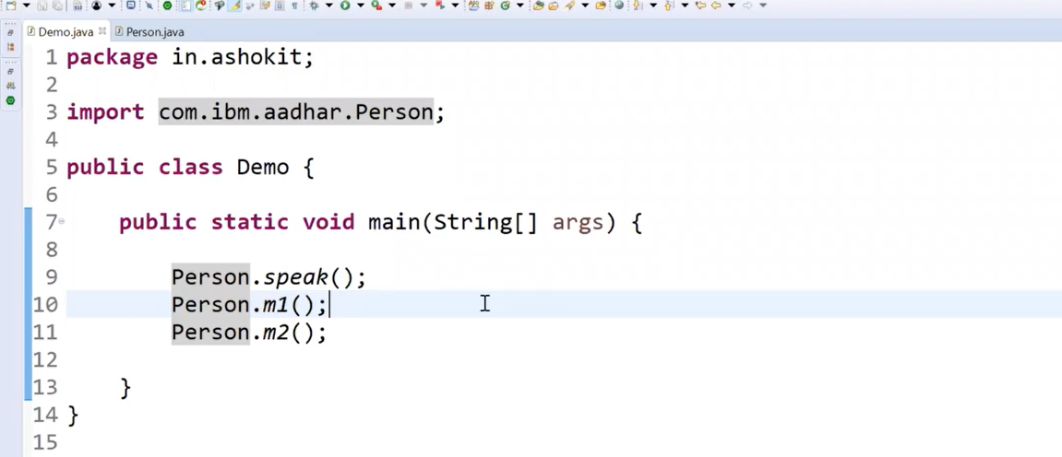
Static Import Use chesaka ( import tag ki static ni add cheyatm)
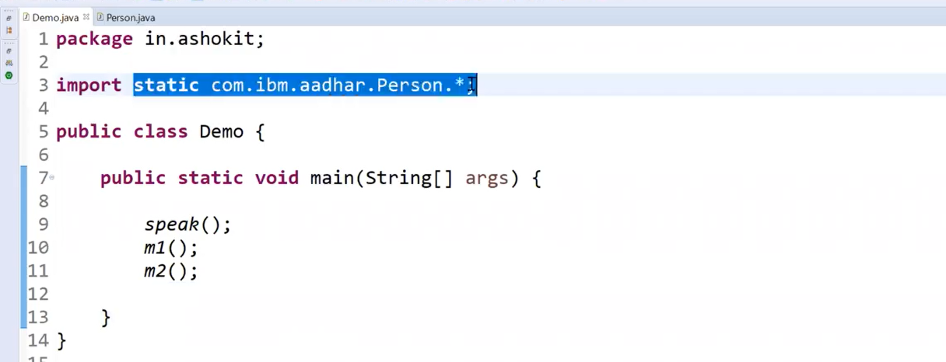
Note : Static import allows us to access static members without using the class name, but it works only for static methods or variables. Not remain insatnces or local

==================== Variable arguments ======================
Variable arguments ane concept Method override ni simplify cheyataniki thisukoni vachharu
Method Override lo same method name tho different parameters ni pampistham daniki multipletime same method ni rasthamu dinni simplefy cheyatanike Variable arguments thisukoni vacchidi

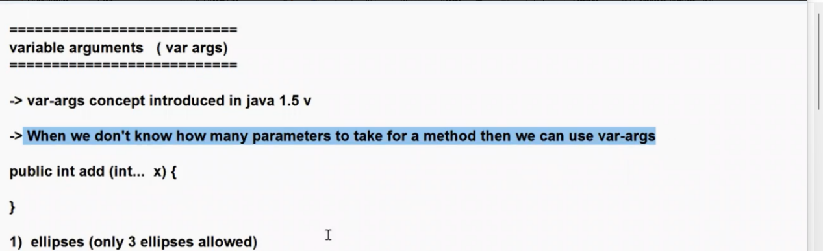
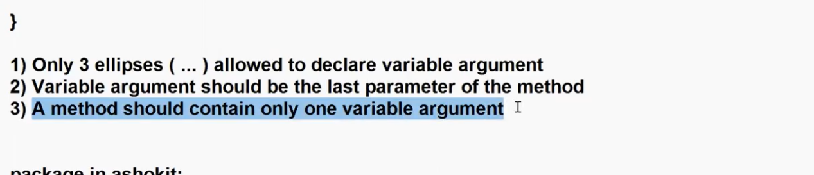

EX : Code

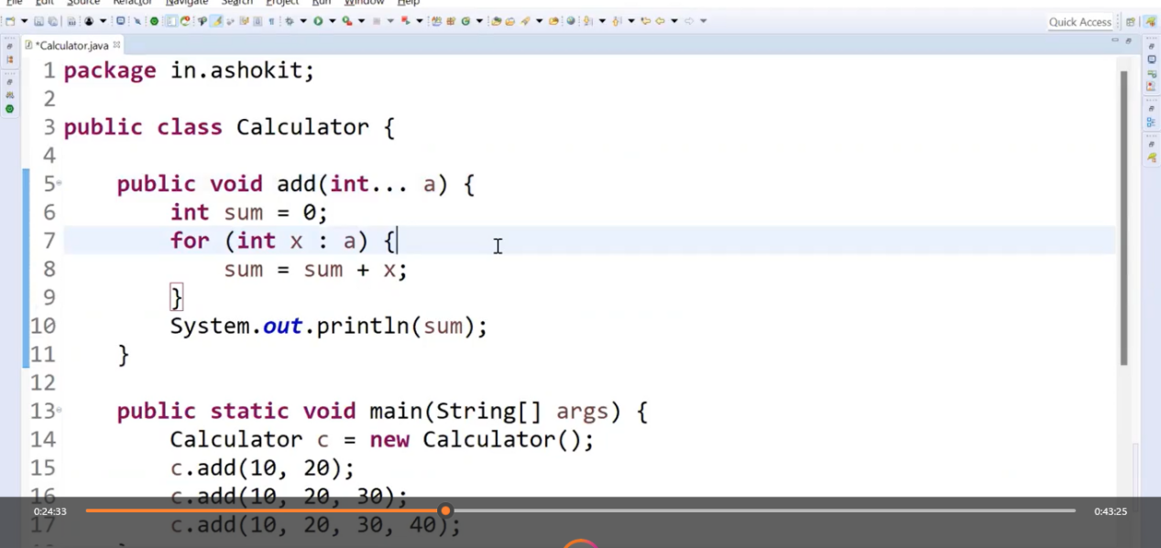

EX : Code 2 : 1 St paramerter ye type avina ecchi a next Variable arguments ni kuda evacchu
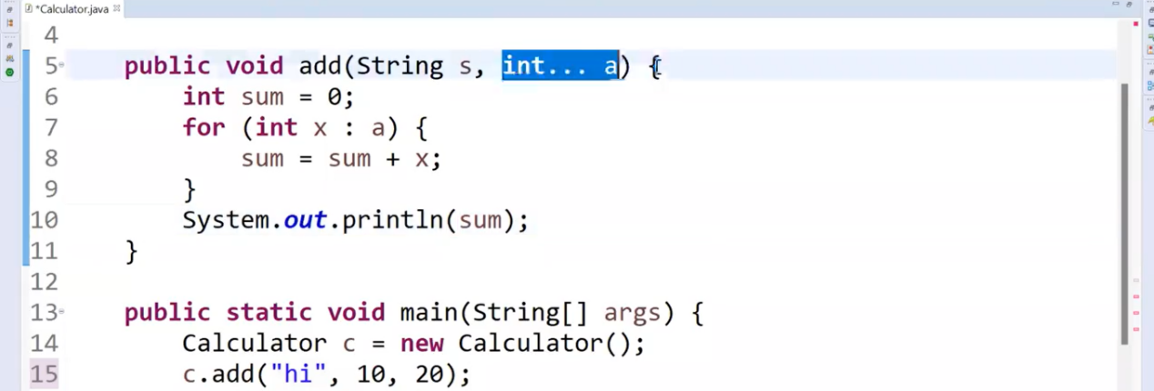

BUT Oke method lo multiple Variable arguments ni evvalemu : Compiletime ERROR vasthundi
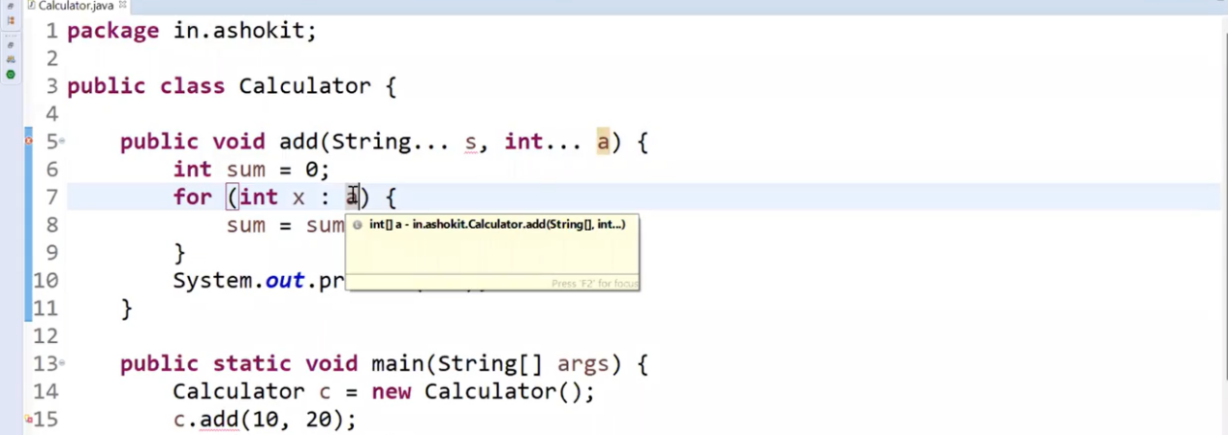

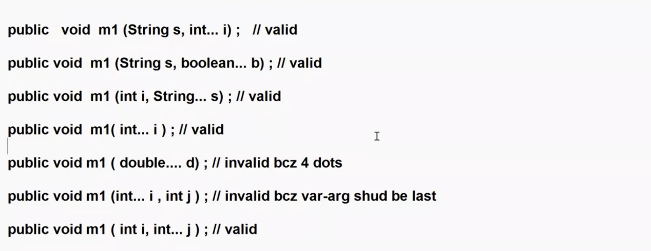

================== Serialization & De-Serialization ===============

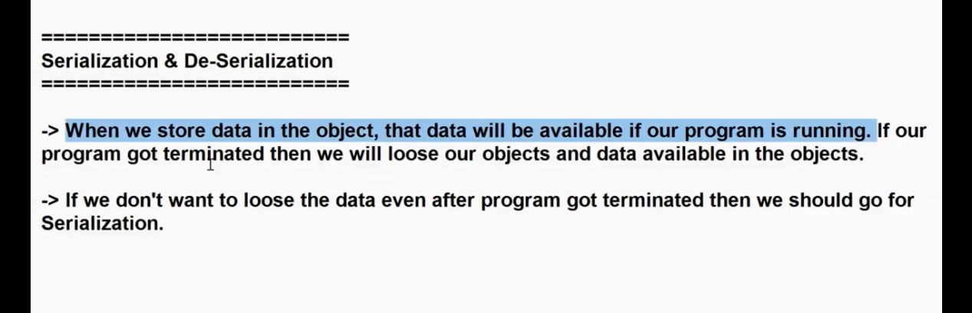
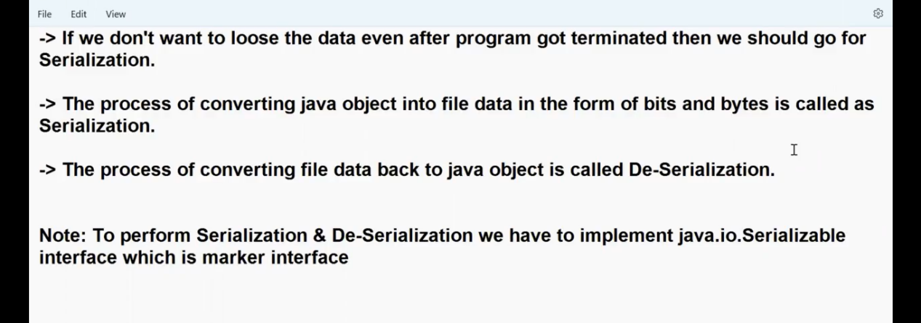

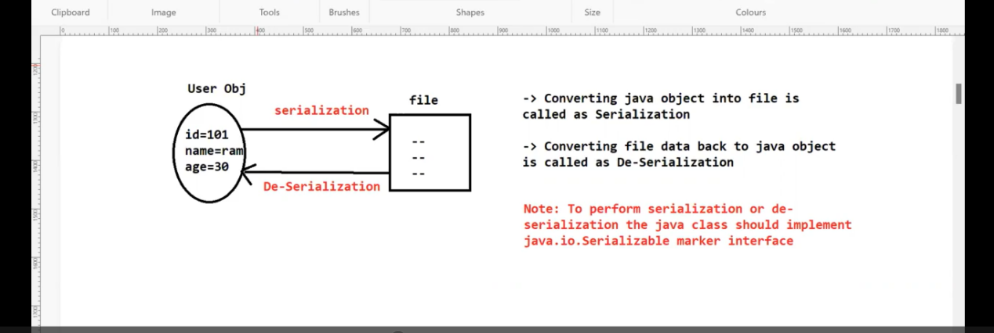

EX : Serialization

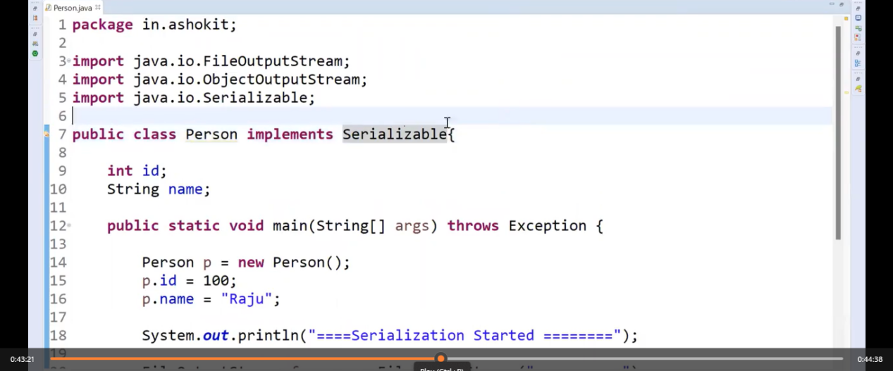
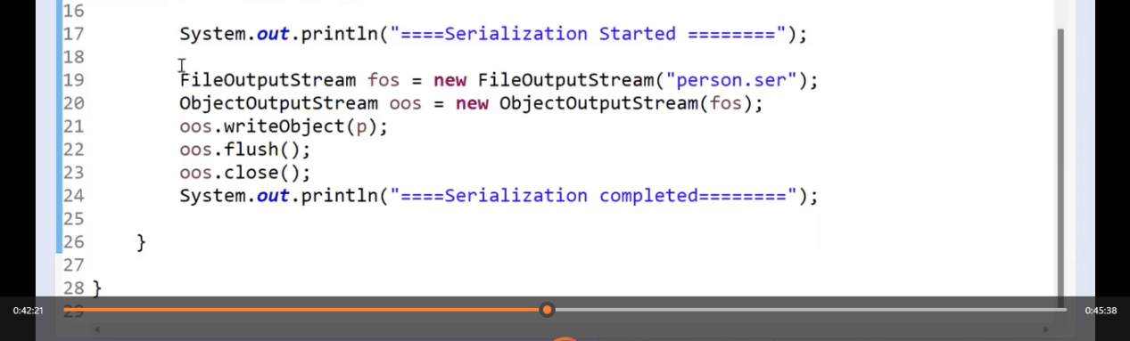

Ex :De-Serialization
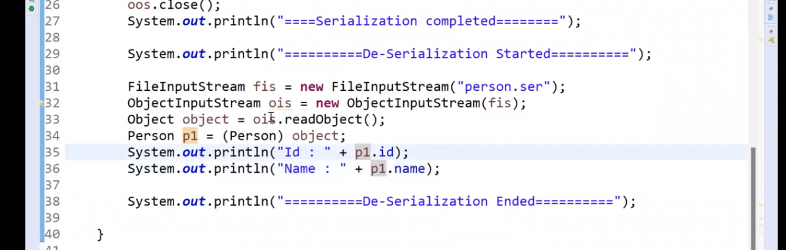

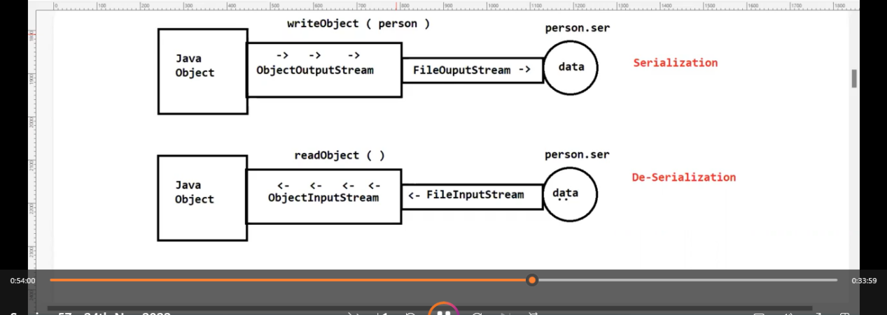

Dropout of Serialization :
Oka sari Serialization code rasi compile chesinappudu .class file ki and Serialization dwara create avina file ki JVM anedi oke serialVerstionID ni eisthundi : so manam De-Serialization chesetappudu Aa ID anedi same avithe De-Serialization avuthundi lekunte avvadu
SO, manam malli yedanna changes chesi code ni compile chesi Aa .class file meda De-Serialization cheyataniki try chesthe Error vasthundi because ID anedi different yendukante malli copile chesinappudu JVM random ga yedo oka ID ni eisthundi ganuka
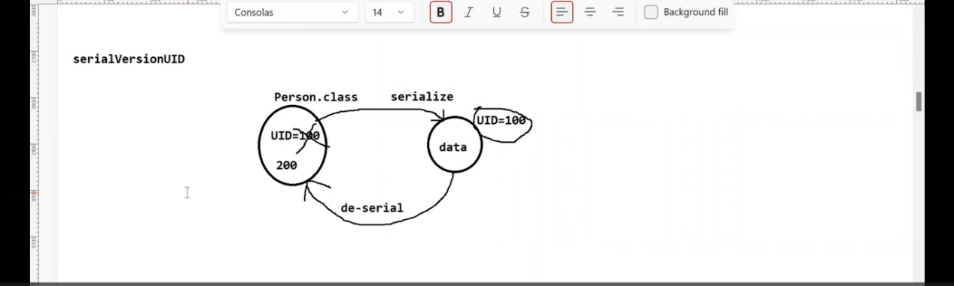
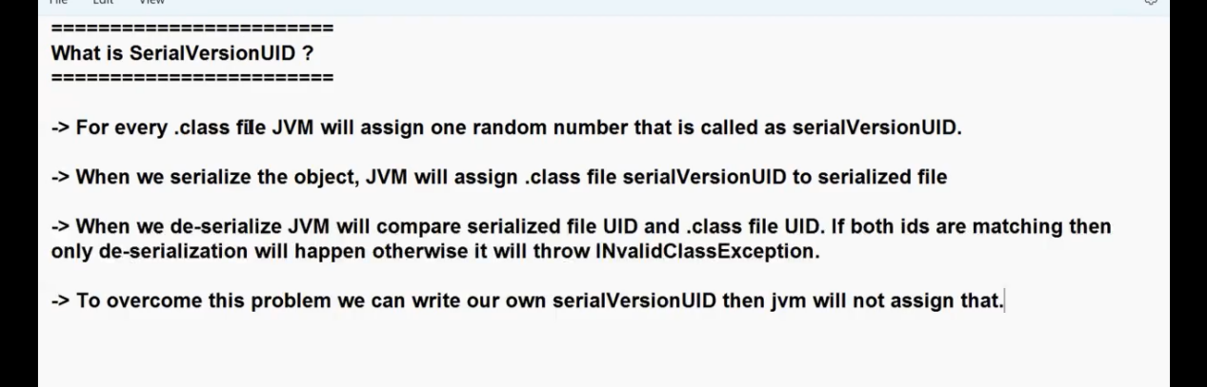

To Over come this Problem we can use our own serialVerstionID ni evachhu
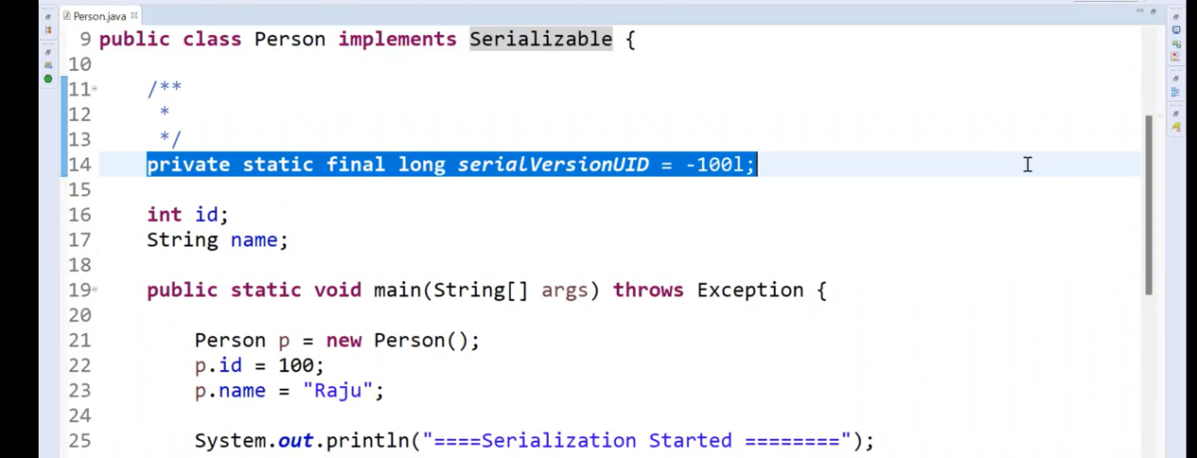

Note : yedavina variable ni Serialization (file lo store) cheyakudadu anukunte transient key word ni use cheyali

Transient ni only variables ki use cheyagalmu not for Static variables or Methods or any others

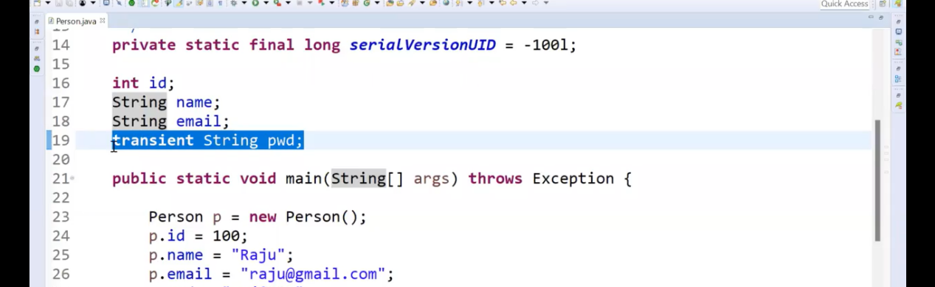

Note : E Serialization & De-Serialization ni Realtime projects lo use cheyamu becase realtime projects lo data ni files lo store cheyamu DATA Base lo store chesthamu

BUT just tpoic thelusukovali kanuka thelusukunnam

Final answer
“Yes, in Spring Boot also databases are used for storage, and serialization is mainly used for converting objects to JSON and vice versa during API communication, handled automatically by Jackson.”

Above Statement correct But not fully “We Don’t Use File Storage in Real Time”?
We do use file-based storage in many real projects.

Common Real Uses

1. File Uploads
- Resume PDFs
- Excel reports
Stored in:
- local disk
- Amazon Web Services S3
- Google Cloud Storage

2. Logs
Applications write log files.

3. Config Files
application.yml

4. Batch Exports
CSV / Excel generated files.

5. Cache / Snapshots / Temp files

Important Real Truth About Serialization
Serialization is broader than JSON.
Used in:
- JSON REST APIs
- Redis cache values
- Apache Kafka messages

Real Spring Boot View

Day-to-day CRUD Developer:
Mostly DB + JSON APIs ✅

Mid/Senior Backend:
Also deals with:
- files
- binary serialization
- object mapping

Straight Answer
Your statement is 70% correct for beginner Spring Boot CRUD apps, but wrong for real backend systems at scale.
Databases store structured data.
Files store documents/media/reports.
Serialization powers much more than JSON.

What You Should Remember for Interviews
In Spring Boot, Jackson automatically handles JSON serialization/deserialization for APIs, while databases store persistent structured data. File storage is still used for uploads, reports, logs, and external storage systems like S3.

Brutal Truth
Many beginners think backend = DB + Controller + Postman.
Real systems involve storage layers, messaging, caching, files, retries, failures, formats.

================================ Threads ===========================================

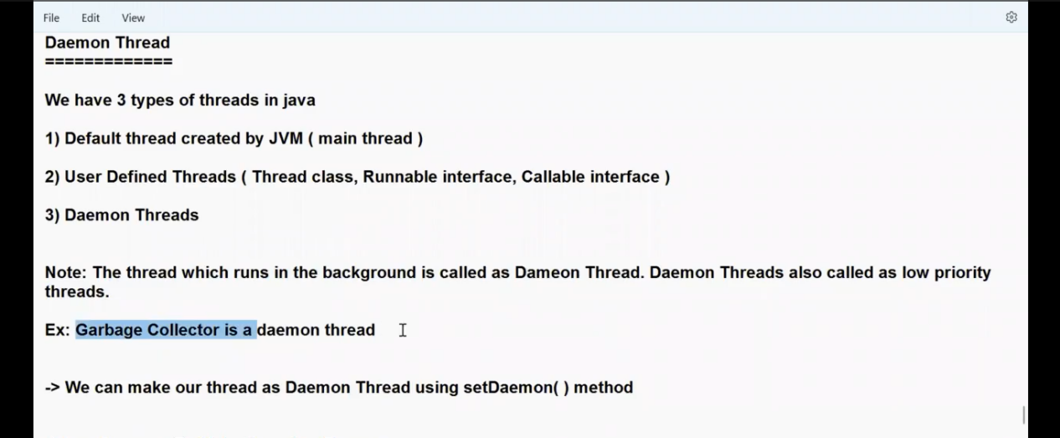

Daemon Thread : is nothing but low priority threads which will run in background :
Create chesina Thread ni Daemon thread ga cheyataniki setDaemon () ni use cheyali…
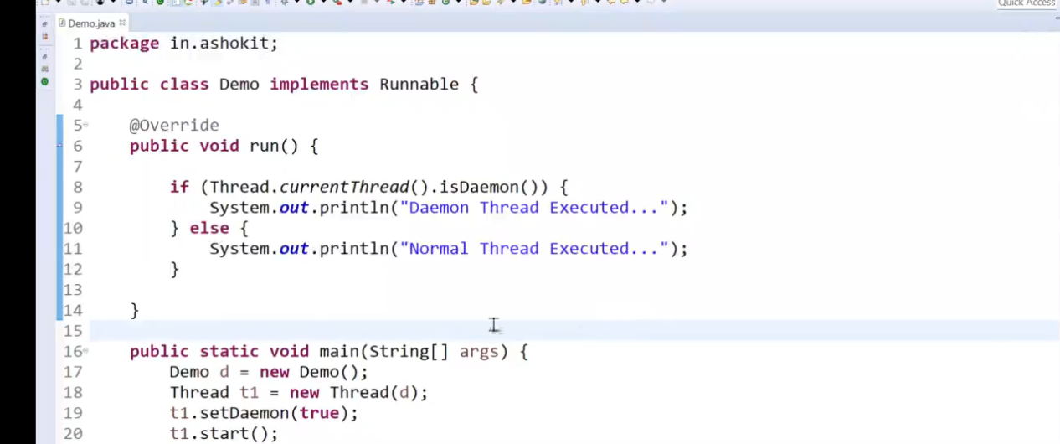

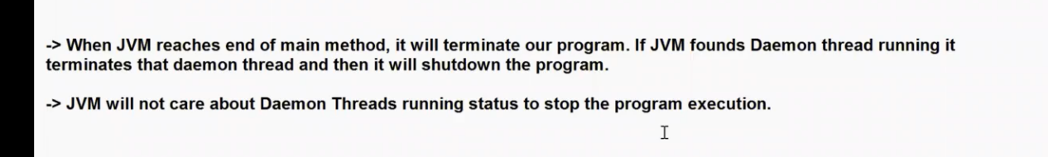

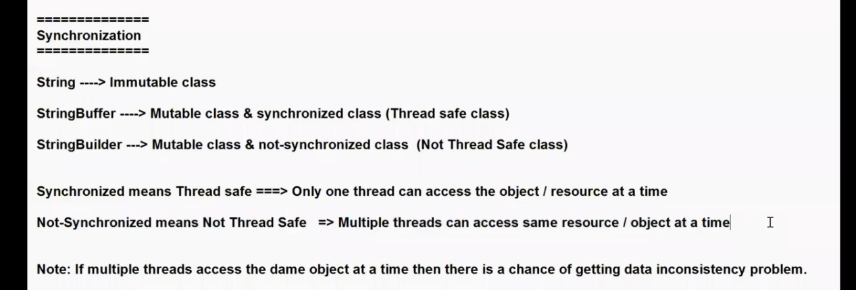
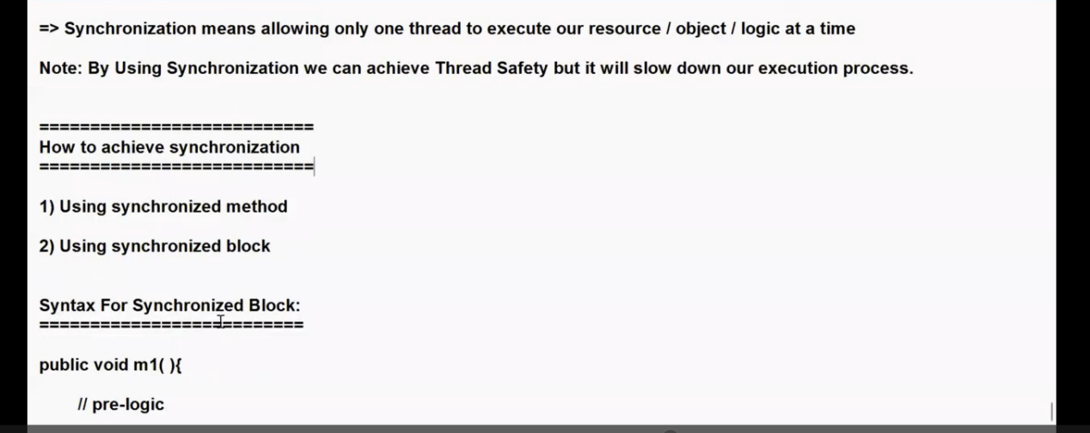
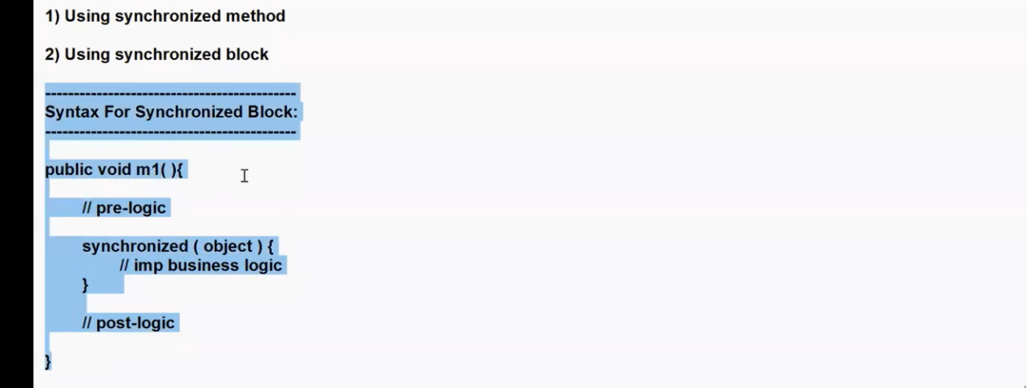

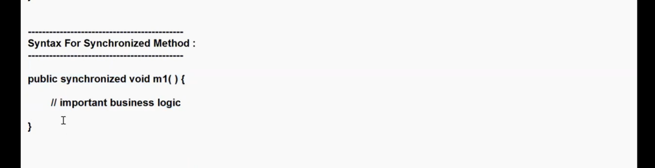

DedLock : Oka Thread veroka Thread kosam wait cheyatanni DeadLock situation antaru : Okka sari DeadLock anedi create avithe program anedi completed avvakunda ala responces kosam agipothundi

Ex Code for DeadLock : oka vela Interview lo DedLock Situation vachhela code rayamani adigithe below code use avuthundi

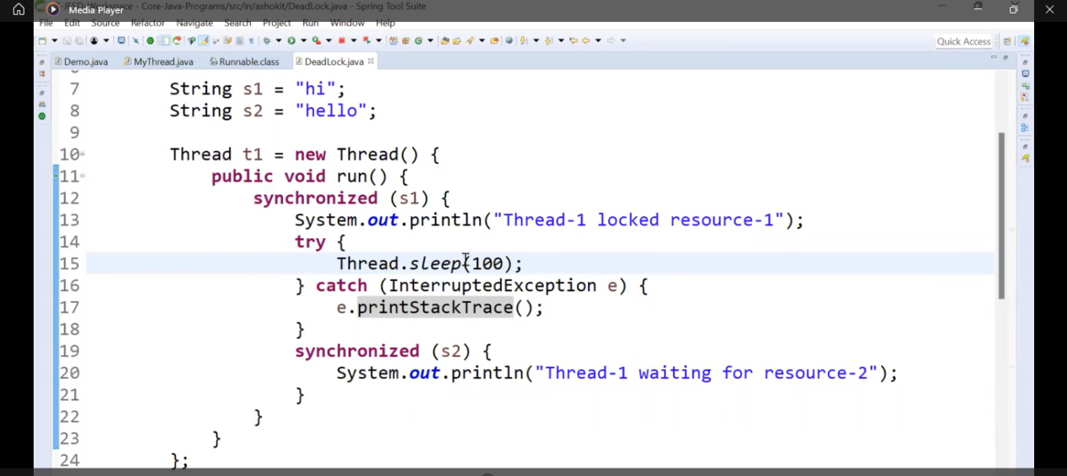
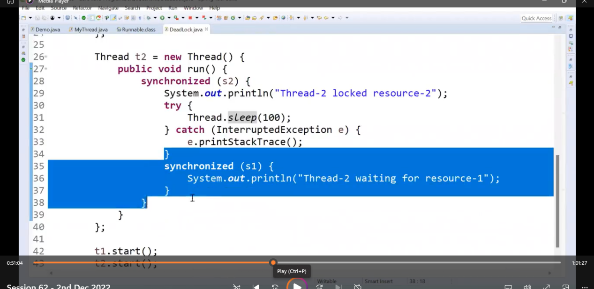
Ex: anedi rayaledu join() ki
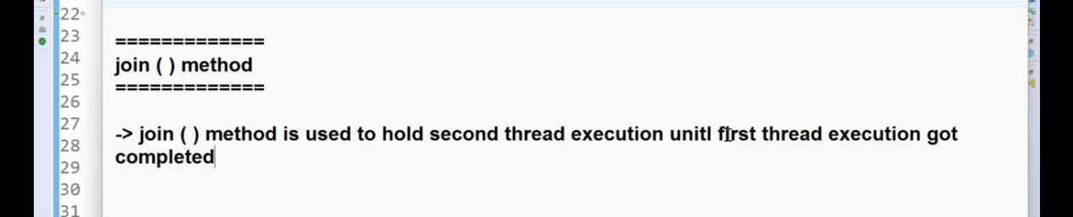
Ex: anedi rayaledu yield() ki
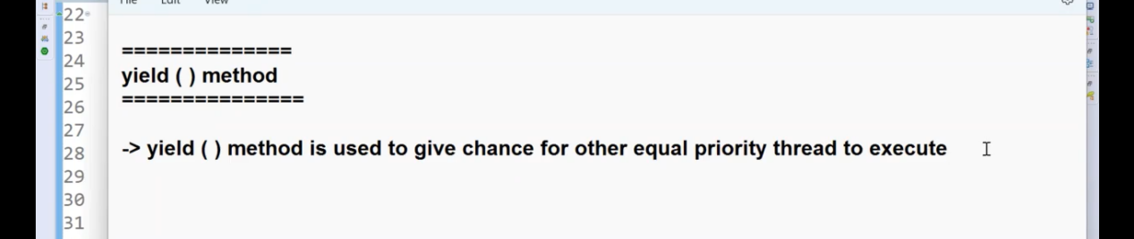

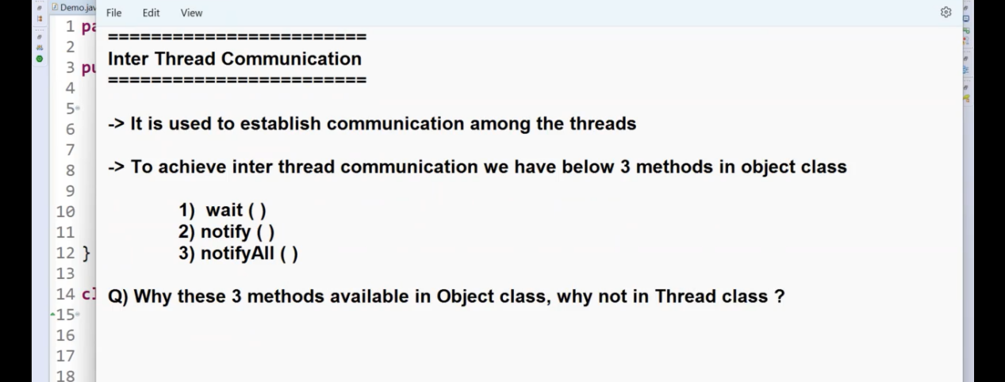
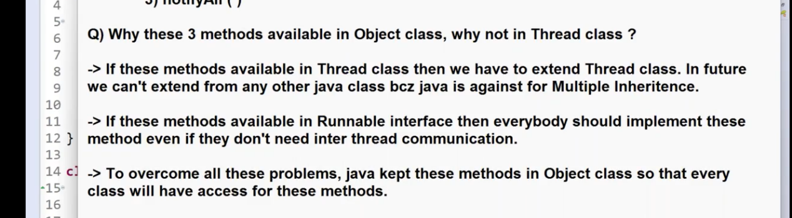
=============================== Reflection API ===================================
Reflection API : oka class lo yem yem methods,veriables …etc eila class lo vunde inform mestion ni return chesthundi : Ala yela eisthundoo chudataniki daniki sambandinchina code rasthe ave vasthayy…
BUT edi not usefull topic because yelago Manam IDE use chestham a IDE maniki a class related all information provide chesthundi : so no use to learn E IDE kuda internal ga E Reflection API ni use chesukone manaki code rasetappudu suggestion display chesthundi
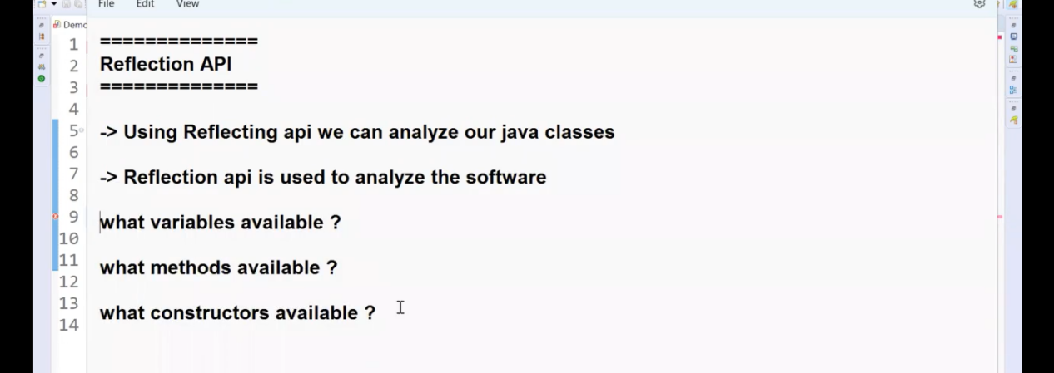

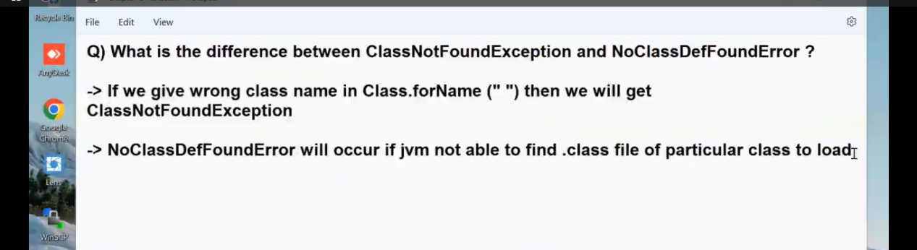

=============================== Enums ===================================
